WWHSDC News
Conference on Collaboration for Sustainable Communities
Nov. 28, 2015,| Written by Edu Banjo
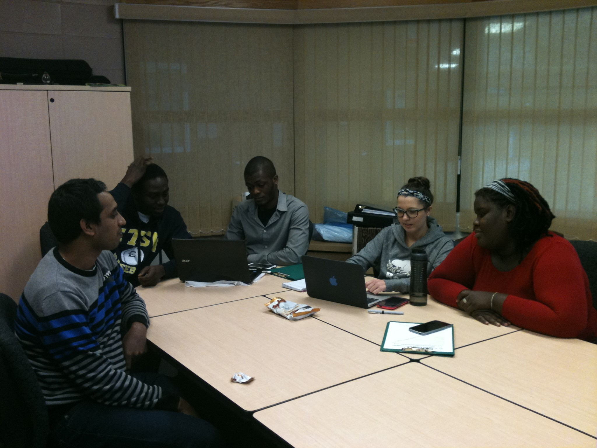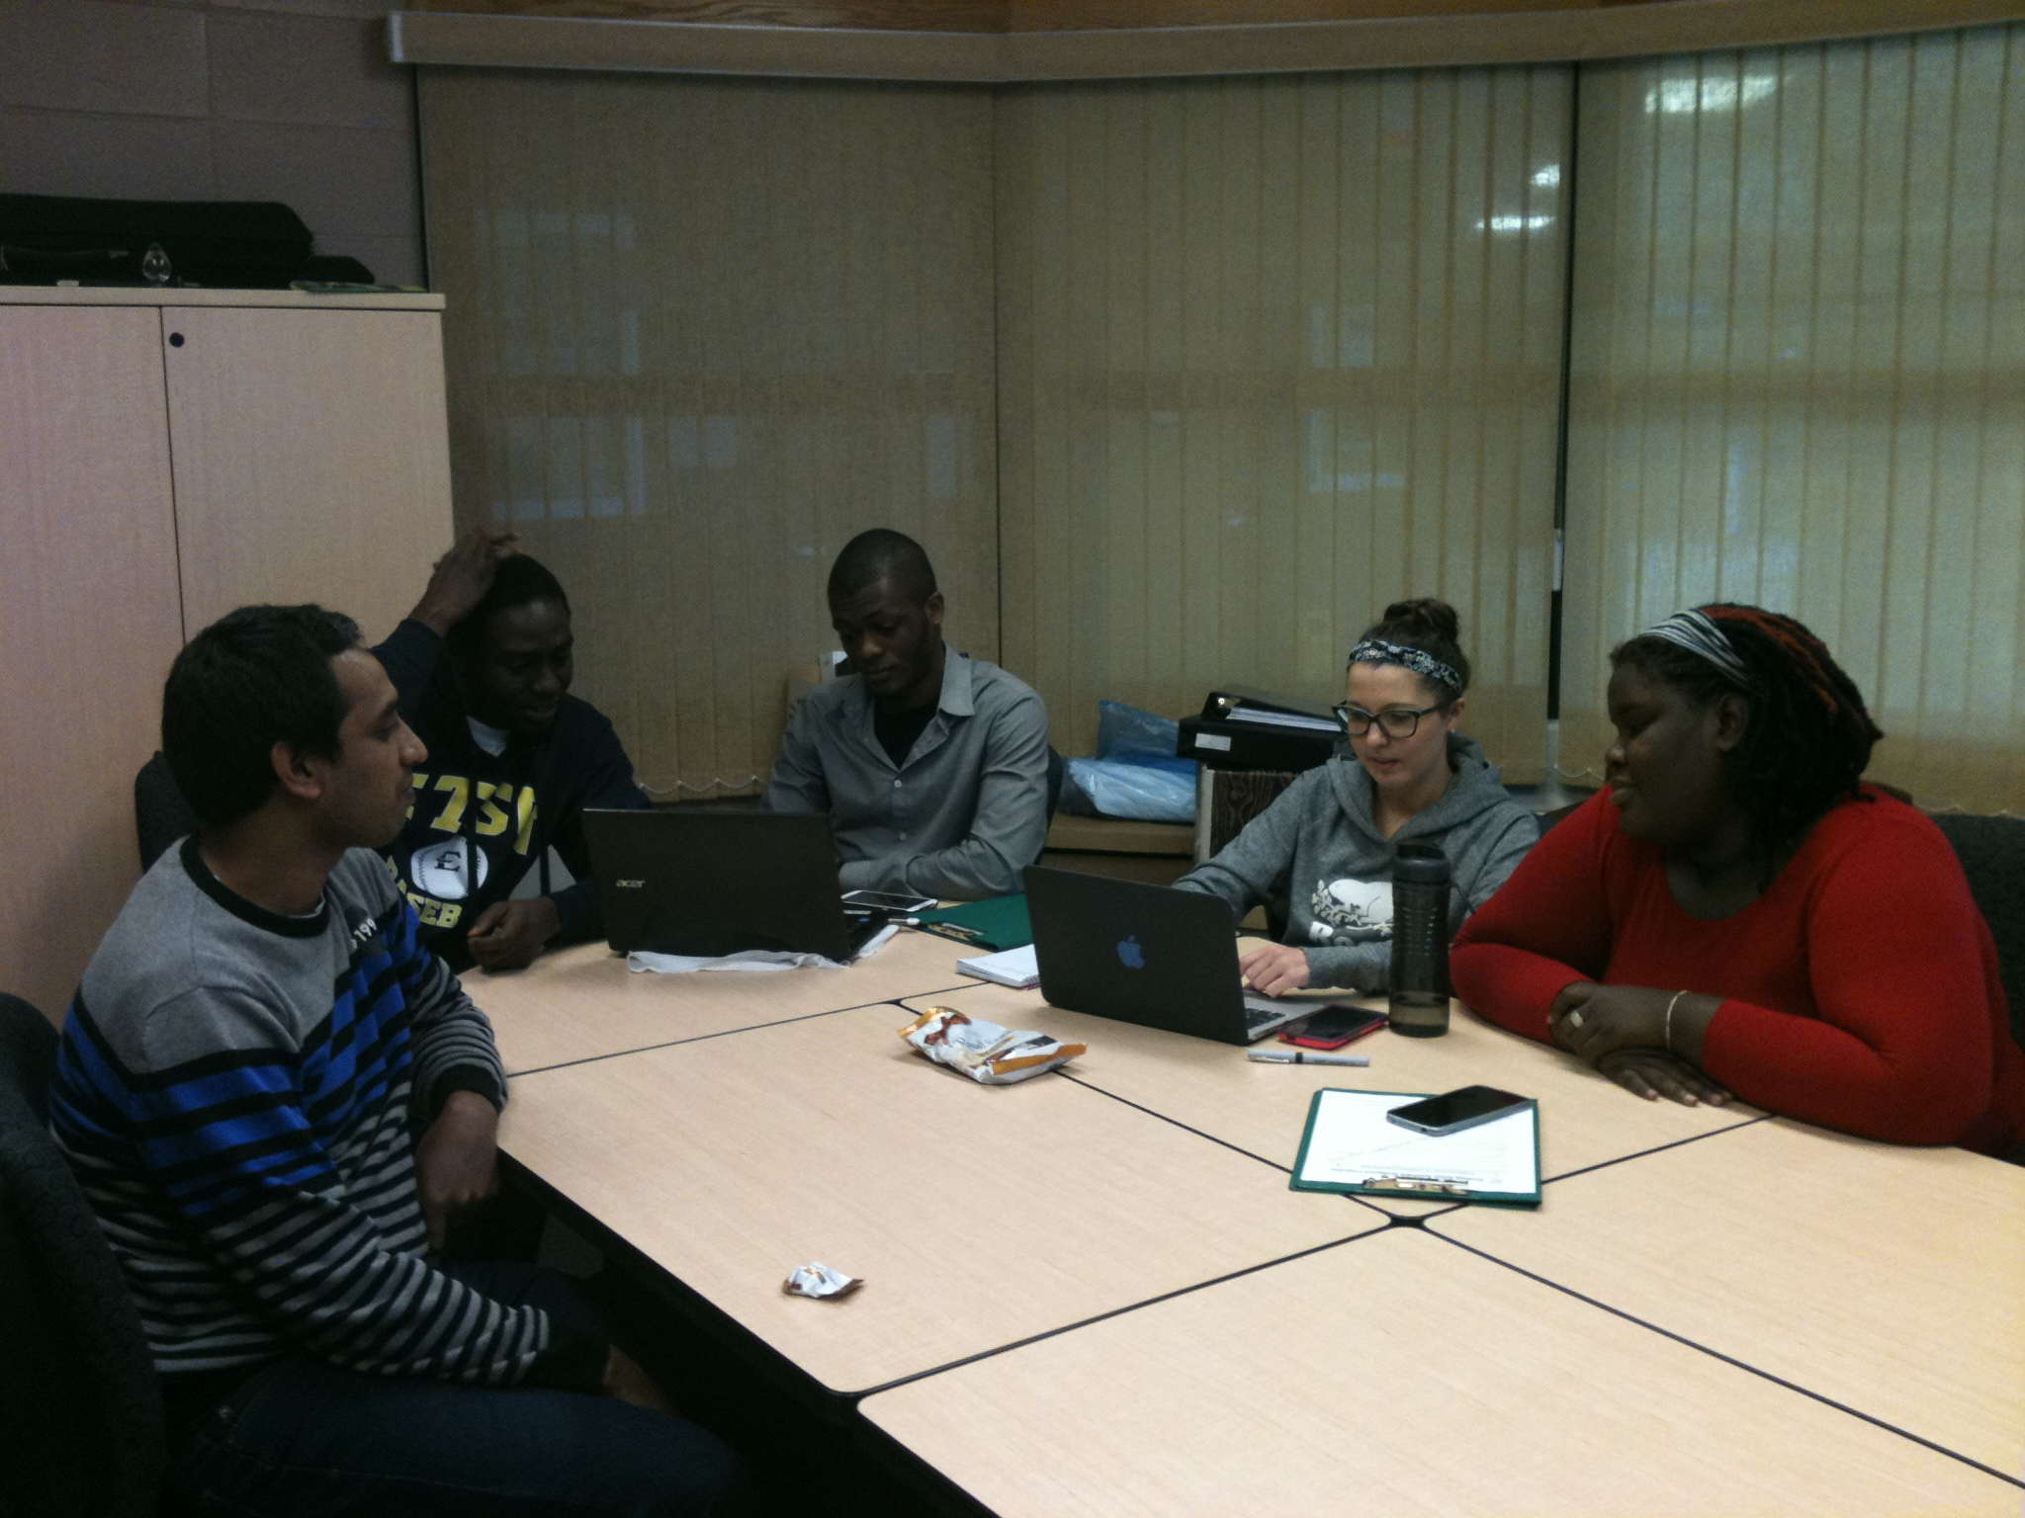
A cross-section of conference organisers
A cross-section of conference organisers
On the 13th of November 2015, the Worldwide Holistic Sustainable Development Cooperation (WWHSDC) will be hosting the Corner Brook community at her Inaugural Conference themed: Collaboration for Sustainable Communities. The conference has been scheduled to take place at the Grenfell Campus, Memorial University of Newfoundland. Founded by Jannatul Islam, Edu Banjo is coordinating the inaugural 2015 conference initiative with support from a group of graduate students in the environmental policy program.
The goal of this conference is to provide a melting pot where the drivers of sustainable initiatives in Newfoundland and Labrador from the academia and the community can share experiences and map a path to continued collaboration for sustainable communities within the province.
With more than 20 presentations, the conference will avail attendees an opportunity to experience cutting-edge research and practices in sustainable development for communities. As a plus, participants will be able to network with notable individuals like; Daniel G. Pottle, Minister of Finance, Human Resources and Information Technology, Government of Nunatsiavut; Sam Elliot, the Executive Director of SABRI, and representatives from the Gros Morne Cooperating Association. Attending from the Grenfell community is Dr. David Peddle, Associate Vice-President (Academic), Dr. Antony Card, Associate Vice-President (Research) and a host of experienced academic professors.
The conference will signal the official launching of the academic Journal for Worldwide Holistic Sustainable Development-JWHSD, which will become a repository of knowledge on sustainable development globally. The event would not have been possible without support from our partners at the Grenfell AVP office (Academic & Research), Environmental Policy Institute, Scholarship in Arts Fund, GCSU, GSU, Engagement Office, Navigate, and the Student Innovation Fund. Please visit our website (http://wwhsdc.org/conference/upcoming/ ) for more information and how to register for this event.
For further information, please send enquiries to Conference Coordinator, Edu Banjo (bedu@grenfell.mun.ca) or Jannatul Islam (jislam@grenfell.mun.ca).

